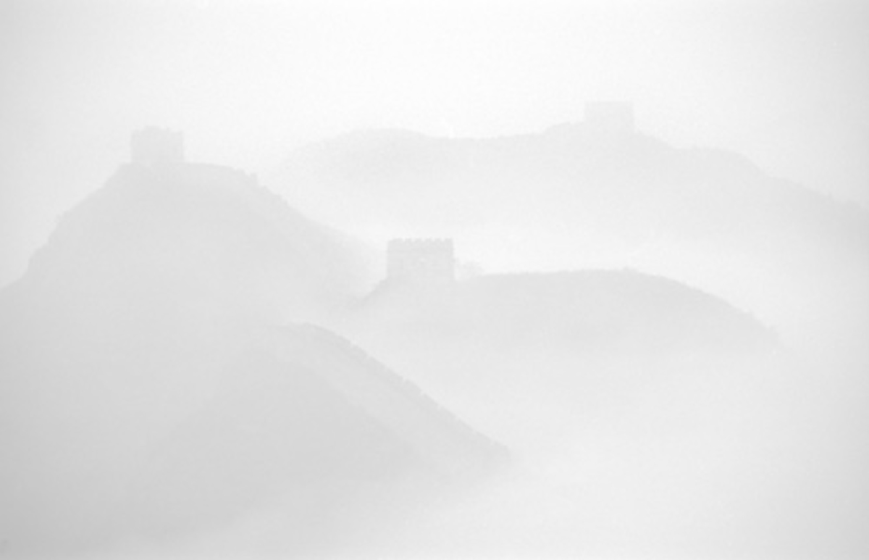

Phoenician Industries

The Great Wall of China
IMAX Theater at Badaling

Introduction
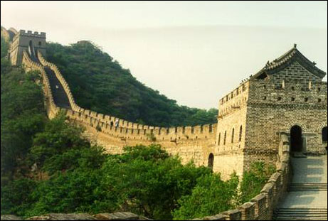
A substantial majority of the top IMAX Theatres are located at destinations such as those at the Grand Canyon and the Smithson-ian Institute. Phoenician Indus-tries has used its strong relation-ships in China to execute an exclusive right to develop agreement with the Badaling Tour-ism Authority, on behalf of the Peoples Republic of China, to locate an IMAX Theater at The Great Wall of China.

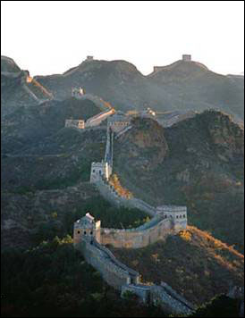
Phoenician Industries is seeking a Naming Rights Sponsor for a beautiful state-of-the-art IMAX Theater and Film to be located at the Badaling Entrance to The Great Wall of China. Phoenician Industries has investors in place to immediately capitalize this project upon agreement of a long-term Sponsor.

Located just outside Beijing, this location is China’s most popular venue for the Great Wall, hosting well in excess of 5 Million visitors per year.

As the saying goes, “You haven’t been to China until you’ve visited The Great Wall.” This is an opportunity for you to enjoy complete sponsorship exclusivity as you win the hearts and minds of millions of annual visitors to one of the world’s greatest cultural monuments as well as the millions of consumers who will view The Great Wall film in distribution at hundreds of IMAX Theaters worldwide for decades to come.

This opportunity will also provide your company with immense exposure and facility usage opportunities to impress and entertain the affluent consumers and key executives who will visit The Great Wall during the 2008 Olympics in Beijing.

The Great Wall at Badaling
The Great Wall of China is universally acclaimed as the world’s number one cultural monument. As a miracle in human creation, it is one of the only man-made objects that is visible from space. As an international destination film venue, it is hard to imagine a more perfect location.
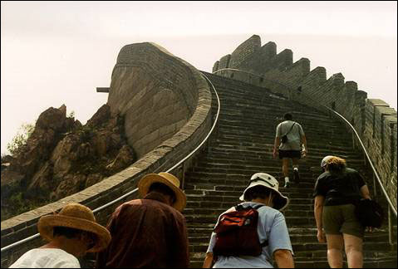
As the essence of The Great Wall, Badaling was listed as a “World Cultural Heritage” by the United Nations in 1987. A new 43-mile expressway connects Beijing to Badaling offering easy access by a 60-minute drive, bus or train ride. Completion of a high-speed magnetic train is expected very soon and will reduce the journey to less than 10 minutes, thereby increasing the number of annual visitors to this location.

Currently, Badaling hosts in excess of 5 Million annual visitors and has hosted more than 120 Million visitors including 360 heads of countries and governments since 1949.

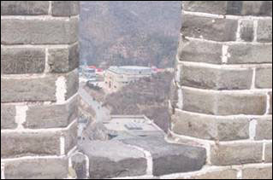
Along with your new IMAX Theater, the Badaling Tourism Authority is planning to distinguish this location by hosting various sporting events such as The Great Wall Triathlon, swimming, boating and climbing events. Present facilities to secure tourist satisfaction include The Great Wall Museum and plans are underway for additional cultural and tourist venues.

View from Wall to IMAX theatre site

Great Wall – The Film
The Great Wall is embedded in the very soul of China. The Great Wall is a story of people’s surviving spirit and monumental achievement wrapped in the history of a great civilization.
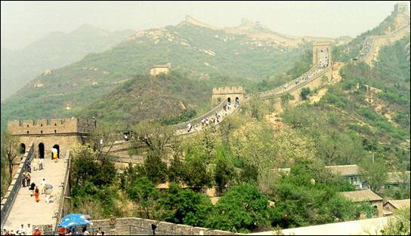
As a joint production between IMAX and Phoeni-cian Industries, the story will be driven by high visual imagery and an original sound track. The musical score will be able to stand alone in classical and traditional music themes to deliver all facets of the sublime beauty of The Great Wall. Full coverage beauty shots with strict attention to methods (superior aerials, state-of-the-art motion control, time lapse, detailed contingency planning) will deliver a full diversity of spectacular images.

Along with the original musical score and magnificent technical pictures, segments of history complete with narration and computer animation will be included.

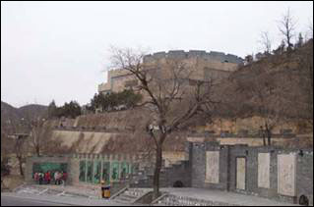
Phoenician Industries will choose its film production team from an experienced group who has worked on several successful IMAX films as well as other projects in China.

The Great Wall of China IMAX film will be a documentary recounting one of the great-est cultural stories of world civilization with seamless continuity.

In addition to the approximately 1 Million consumers who annually visit your IMAX theater, your Great Wall Film will be distributed to hundreds of IMAX theaters and shown to a worldwide audience averaging approximately 1.7 Million consumers annually.

Annual Film Audience

Your Great Wall Theater
Audience = 1,000,000

Worldwide Distribution
Audience = 1,700,000

Total Annual Film
Audience = 2,700,000

Entertainment with Purpose
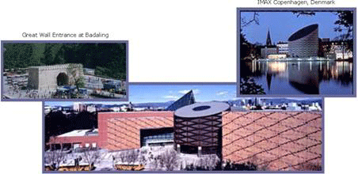
The IMAX brand has evolved as one of the most powerful and most recognized brands in the entertainment industry. Consumers around the world identify IMAX theaters with providing fascinating and enlightening entertainment experiences. IMAX entertains with a purpose, through the core values of entertainment, enlightenment and innovation. Science Center IMAX

The IMAX brand delivers a promise to over 70 million consumers who visit over 280 theaters worldwide each year. IMAX fulfils consumers’ expectations by providing a cinematic experience that is founded on technical superiority.

Through consumer research provided by the Angus Reid Group, IMAX has learned:

- One of the incredibly positive powers of an IMAX theater is its association with its institutional and cultural heritage
- This association had a positive “halo” effect on IMAX theaters
- Consumers recognize IMAX as a unique and immersive experience.

In fact, according to the study, brand recognition has leaped from 29% in 1993 to over 60% in 1997 and even higher today.
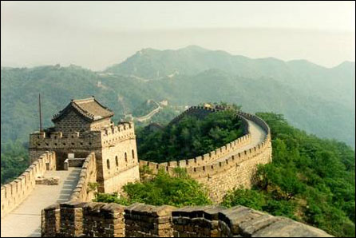
Your Badaling IMAX theater will provide millions of consumers a truly exceptional entertainment experience combined with an educational value that will surely be a cherished memory of their visit to The Great Wall of China.

More than 9 out 10 visitors continue to recommend the IMAX Experience to friend or relative.

IMAX Success in China
On February 10, 2003 IMAX Corporation announced that it signed deals for the completion of three additional theaters, bringing the total number of IMAX theaters to be open in the People’s Republic of China by 2005 to eight. This makes China the fastest growing IMAX market in its 35 year history.

“To be part of three major developments just six months after our official launch in China demonstrates the continued demand for IMAX theaters around the world, particularly in China,” noted co-Chairmen and CEOs Richard Gelfond and Bradley Wechlser.

Leng Xiaoming, Deputy Mayor of the People’s Government of Dongguan City added, “IMAX theaters have become an integral part of science centers, museums and cultural centers around the world. We are excited to be able to provide our future visitors with powerful and unique educational experiences that transcend culture, language and even politics. IMAX has already proven successful at the Shanghai Science and Technology Museum where hundreds of thousands of Chinese have been inspired by the IMAX Experience.”

3 out of 4 consumers feel that a visit to an IMAX theater is worth more than a conventional cinema. In fact, the majority would pay a $2 premium and 33% would pay a $3 premium.

Your IMAX at Badaling

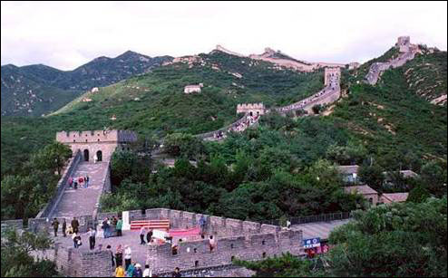
Since the opening of the first permanent IMAX theater at Toronto’s Ontario Place in 1971, IMAX Theaters have made spectac-ular architectural statements, gaining worldwide recognition for their innovative designs.

IMAX is a very special adventure that starts outside the building and then continues inside. Because IMAX films are shown on such an enormous screen, the building must be a unique, monolithic architectural experience.

You now have the opportunity to attach your name and identity to a beautiful state-of-the-art IMAX theater that is highly visible at the most popular entrance to one of the greatest cultural attractions in the world.

Your unique theater will hold approximately 600 consumers with seats that tilt back to allow the viewer a comfortable and comprehensive view.

The extraordinary Great Wall Film presented at your theater will serve as a means by which you provide visitors an understanding of one of the most popular cultural attractions in the entire world. What will happen in your theater is so realistic, that no one leaves untouched by the experience you have provided. The giant IMAX screen, approximately seven-stories high, shows an image of stunning clarity. The IMAX Dome extends the experience even further by surrounding the visitor with brilliant, absorbing images.

IMAX Audience Profile
Age

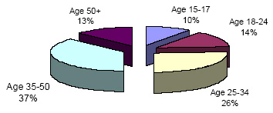
75 million consumers visited IMAX theaters in 2002

70% of IMAX visitors are from middle to upper class families.

On average, IMAX audiences drive 25 miles to visit our theaters – it’s an event!

Income
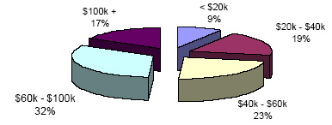
49% of IMAX audiences earn over $60,000 annually.

54% of IMAX audiences have a college degree or more.

Education
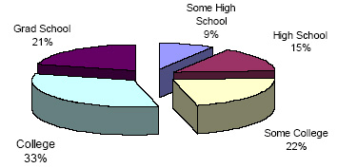
90% of IMAX audiences are extremely or very satisfied with their experience.

89% are extremely or very likely to recommend IMAX theaters and films.

Gender
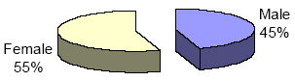
79% of IMAX audiences find the IMAX Experience a good value for the money.

On average IMAX consumers visit an IMAX 2 times per year.

Note: All demographic information provided by IMAX Corporation

Additional Exposure

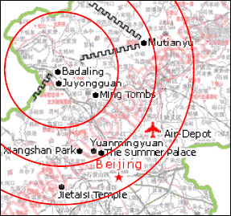
Beijing thrives today as the political and cultural capital of China as well as center of international activity.

Your IMAX at Badaling is within 45 miles of Beijing, which now has a population exceeding 12.5 million.

Virtually every hotel, the Tourism Authorities and everyone else in the tourism business offers tours to The Great Wall at Badaling.

Your IMAX Theater will receive recognition and mentions in tour packages as well as media, advertising and promotion regarding The Great Wall at Badaling.

According to Nielsen Media Research, China’s advertising market, worth $10 billion in 2002, is set for double-digit annual growth and should overtake Japan to become the world’s second largest advertising market.

By sponsoring The IMAX at Badaling you can establish a firm foothold in perhaps the largest remaining untapped consumer market.

China has become a very attractive locale for regional headquarters and R&D centers for international corporations. In fact, 110 of the Fortune 500 companies have established centers there including companies from India, South Korea and Japan.

Beijing is also experiencing a significant boost in the number of regional headquarters and logistic centers established by foreign companies.

Over 15 Million people live within 50 miles of your IMAX Theater.

Over 1 Million people will visit your IMAX Theater each year.

Sponsorship Elements

Theater Overview
- $20 Million project
- Brand new 600-seat state-of-the-art IMAX Theater
- Giant 7-story screen housed in a unique, monolithic architectural experience
- The finest motion picture projectors and sound equipment in the world

Sponsorship Objectives
- Create perceived ownership with the finest venue at the world’s #1 cultural attraction
- Provide top level national and international association with The Great Wall of China
- Capture target audience in one of the largest, fastest growing and untapped consumer markets
- Position naming rights partner as an integral part of the Badaling and Beijing communities
- Build Brand visibility and awareness through over 100 Million annual consumer impressions
- Create an immense amount of additional exposure through continuous press releases
- Drive sales and business development through corporate event hospitality, on-site promotions and community promotions
- Gain massive quality exposure during the 2008 Beijing Olympics
- Take advantage of the world’s second largest advertising market

Audience & Exposure
- Annual theater attendance of 1 Million
- Annual worldwide film audience of 1.7 Million
- Annual Attendance at Badaling Entrance to The Great Wall of well over 5 Million
- Annual extended audience of over 15 Million
- Film trailer shown to an annual IMAX audience of over 75 Million

On-Site Exposure
- Exterior signage
- Interior signage
- Concourse displays
- Strategic corporate logo placement

Comprehensive Media Package
- Print advertisements
- Presence in massive worldwide press release campaign throughout entire sponsorship
- Extensive website and Internet exposure
- Co-Op advertising exposure with local Tourism Authorities, tour companies and hotels
- Presence on front of tickets that will be kept as souvenirs
- Presence on any take-home and/or promotional material regarding your IMAX theater

Hospitality & Facility Usage
- Facility usage for corporate entertainment events or presentations
- On-site promotions
- Extended usage and promotions during 2008 Beijing Olympics

Worldwide Film Exposure
- Name in film title as presenting sponsor
- Product placement in actual film (where appropriate)
- Presence in film trailer to be shown to worldwide IMAX audience

Official Status and Exclusivity
- Complete sponsorship exclusivity*
- Theater logo and name usage rights in any corporate communication and marketing pieces

* exception being only from use of a separate pouring rights partner

